**Pi (DONE ALL IN TERMINAL)**

Install NOOBS by going to (https://www.raspberrypi.org/downloads/noobs/)

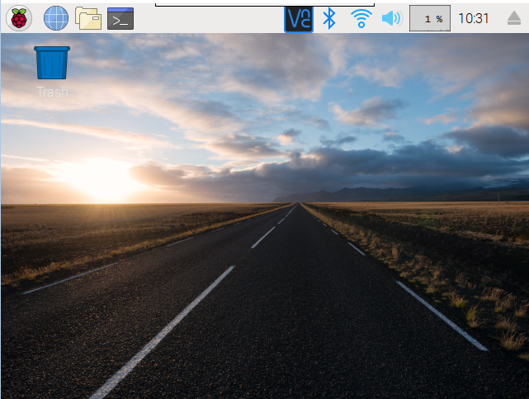

(Should look somewhat like this)

**GPS**

(Connecting GPS to Pi)

* Connect to voltage with Red wire
* Connect to ground with Black wire
* Connect to RX with Green wire
* Connect to TX with White wire

(Make sure antenna and GPS is supplied with power)

{Lights should be blinking, if it’s working}

**GPS Daemon**

The daemon is installed to display the data that is received from the antenna and the USB.

To set up the daemon the code below will initiate the install:



Disable the gpsd systemd service: 

Before you use USB:



Determine USB;



(Should be USB0)

**(Check your wires)**

Make sure you have

Green to RX

White to TX

(Other wires should be ground and voltage)

Code:

**Starting GPS**

Change some settings inside default



Set DEVICES=”/dev/ttyUSB0”

Set GPSD_OPTIONS=”-n”

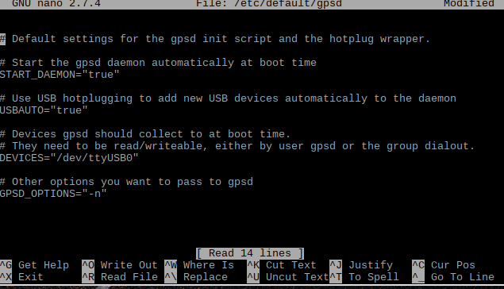

(Looks like this when done)

+Enable gpsd.socket again



(Finished GPS setup)

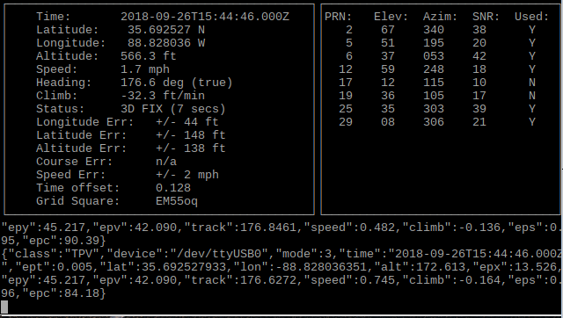

Installing Navit

Paste command in terminal to install navit:



Run navit and exit

Optional: Get OpenStreetMap on USB drive for map on navit.

Transfer file to /home/pi/.navit

Copy setup folder to home directory:



Editing navit config file w/sudo nano

Removing default map and replacing it:

(Zoom)



(Setting Map)

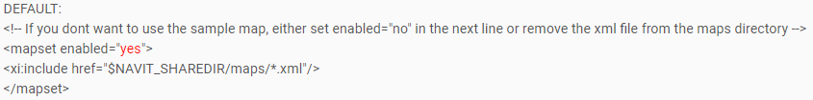

Change to

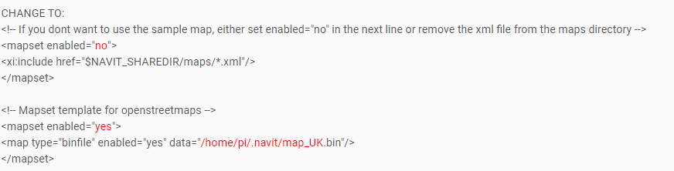

(Adding Compass)

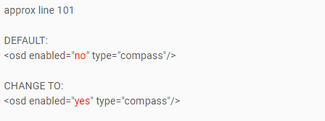

(Adding zoom buttons)

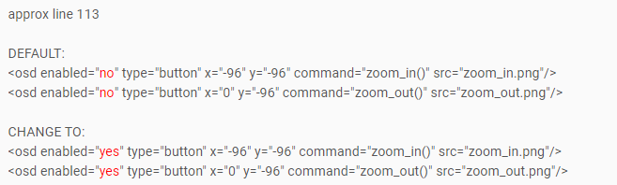

Installing Add-ons

<https://github.com/idorel77/skin.CarPc-Carbon>

Go to the link above.

Download the file using the “clone or download button”

Transfer the file to the pi.

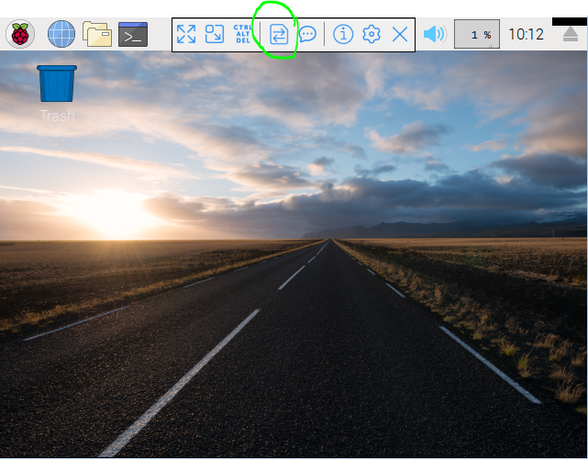

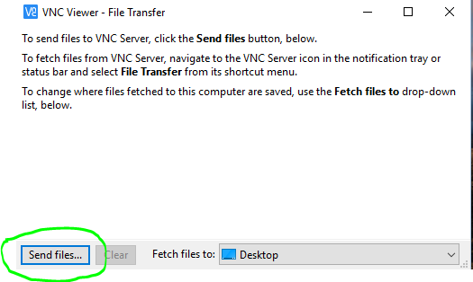

Chose the file of the skin

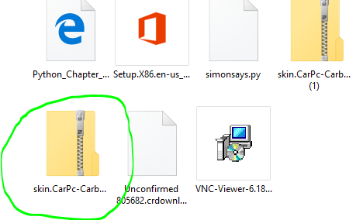

Pick the skin and accept.

Now boot up kodi.

Click the gear icon.

Now click on add-ons

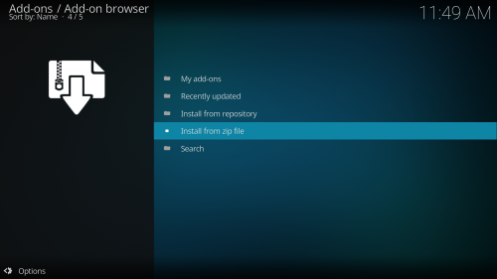

Click on install from zip file (enable unknown sources)

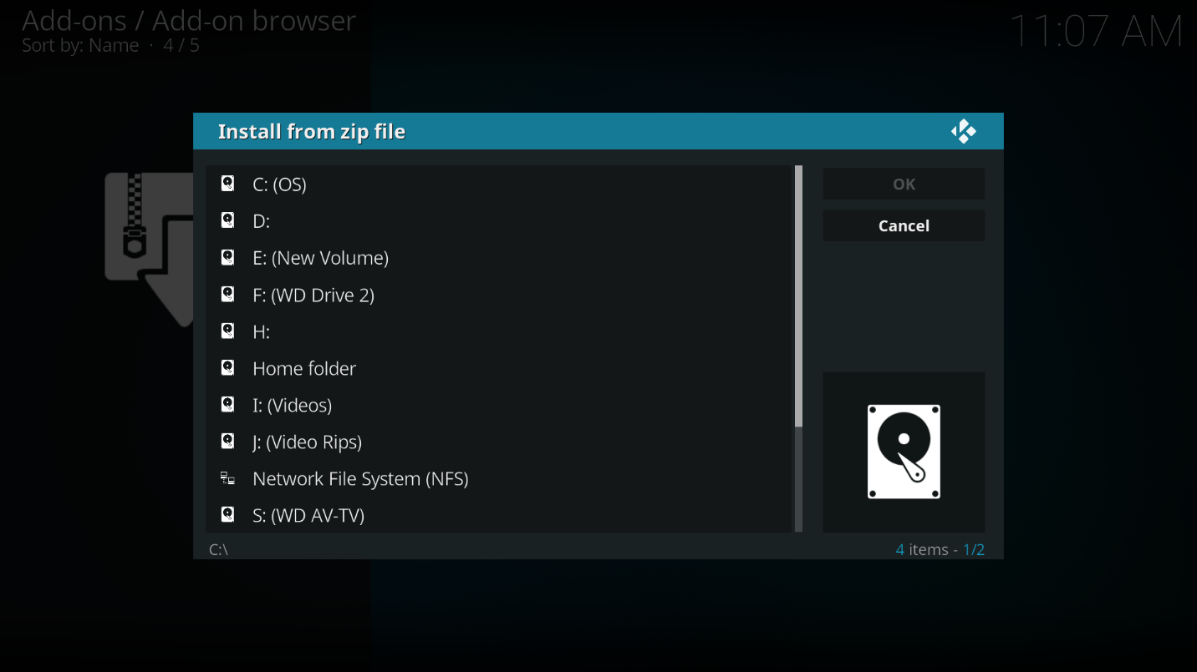

Select the skin (then click yes on both options that show up)

**Music**

sudo apt-get install moc

(insert medium containing music files)

-mocp then search for your music files

Highlight the file then you can play your music